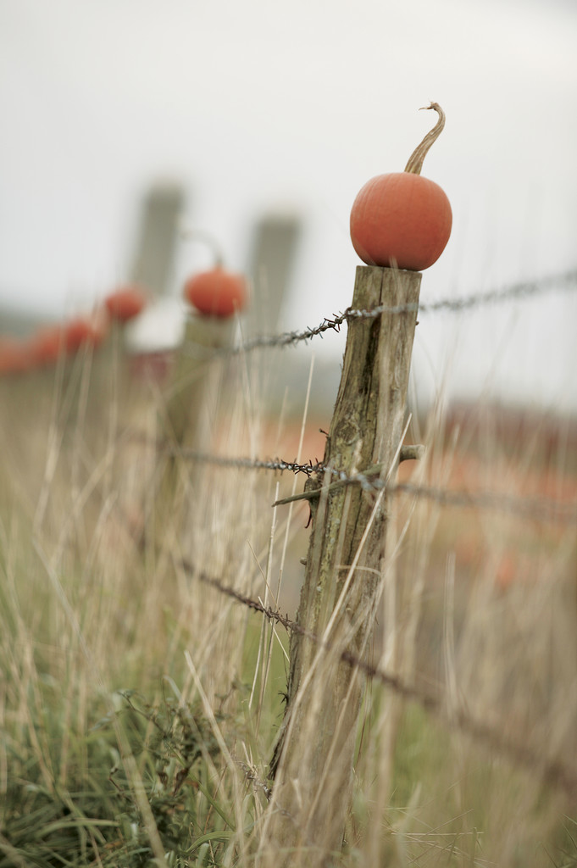

Members Matter Most

International Credit Union Day

October 18, 2012

*We believe that our members are the*

*heart and soul of our Credit Union.*

All members are invited to join us for refreshments as we celebrate Credit Union Day. Also, during the week of October 15 – 19, members are encouraged to sign up for daily drawings.

Not a member yet? Call or stop by for a visit.

Sab R CU logo-black.eps

2 Middle Rd., Sabattus * 207-375-6538 * 1-800-503-0434 * [www.srcu4u.com](http://www.srcu4u.com)

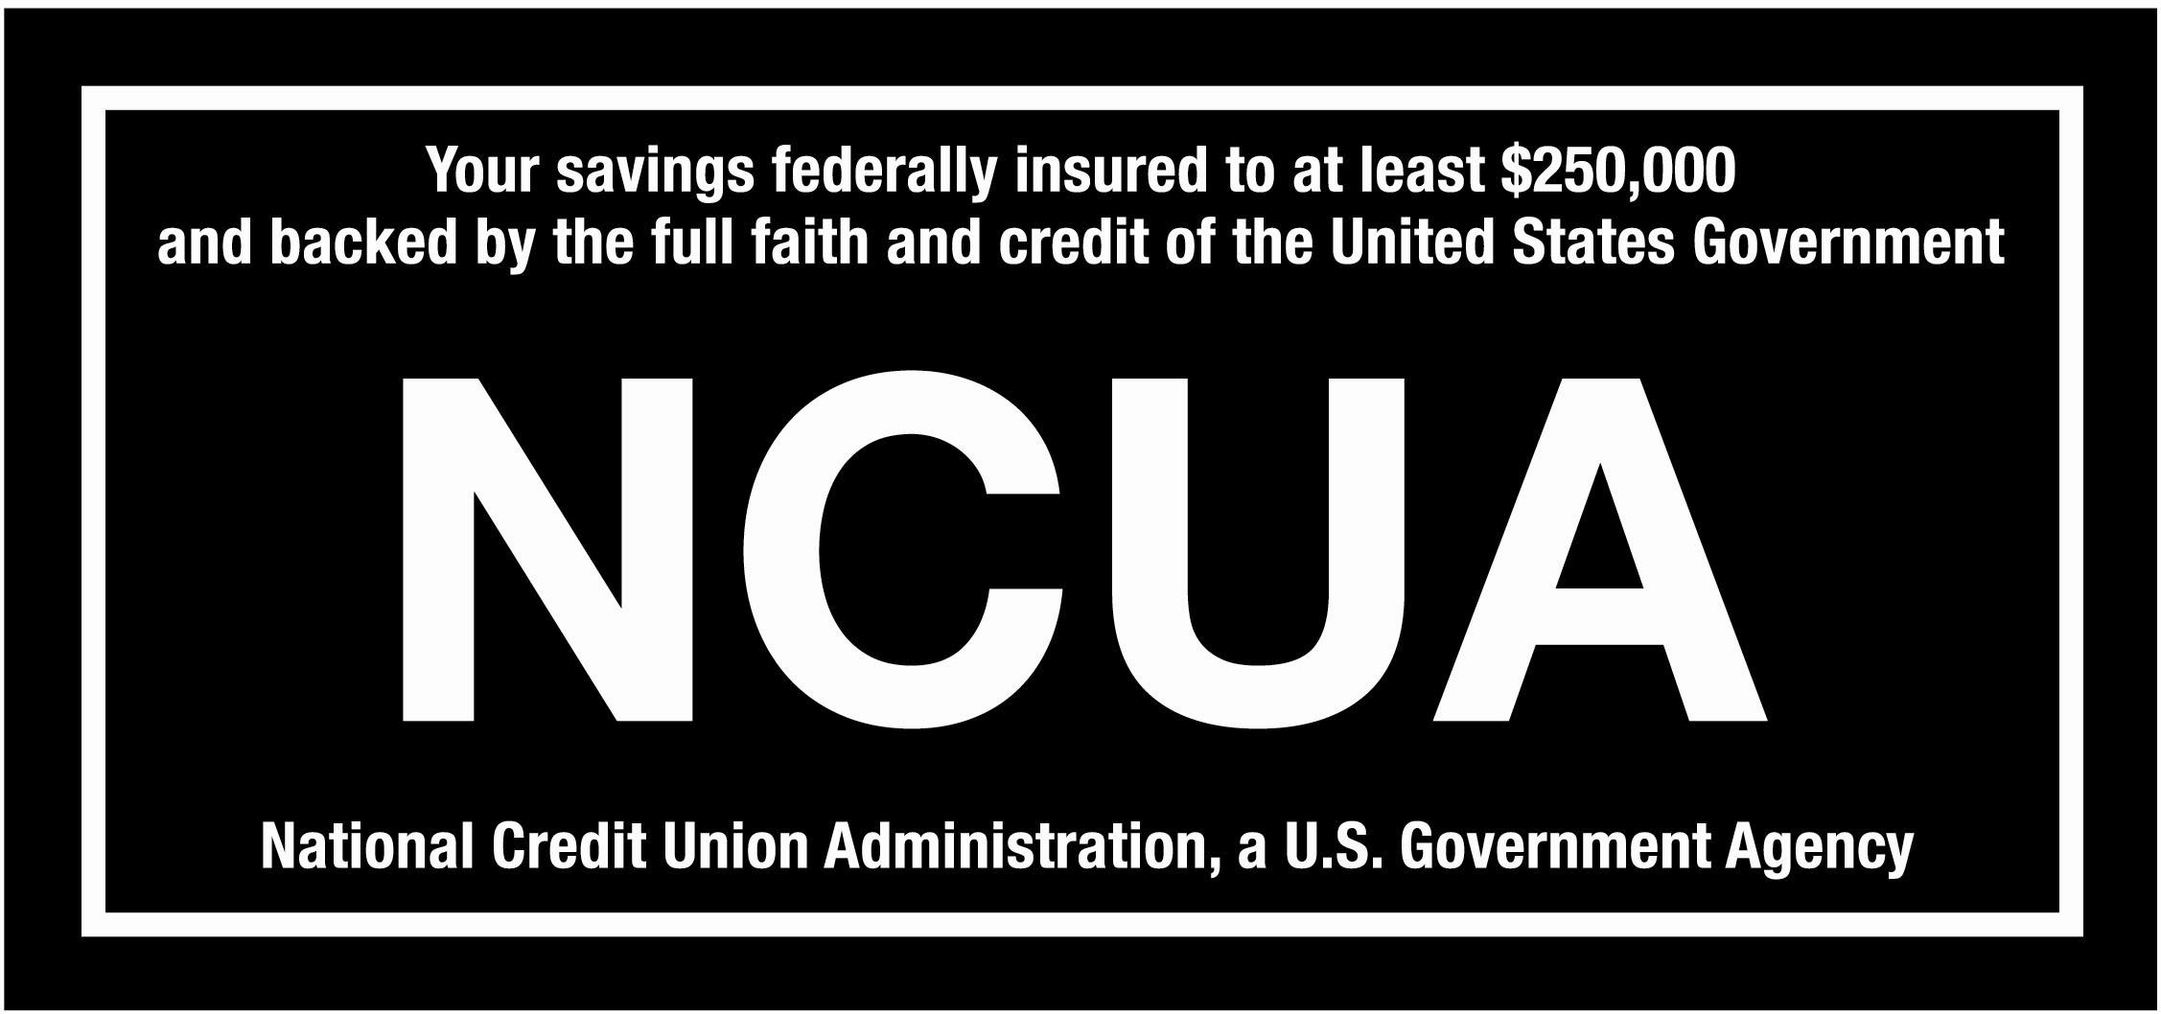 **[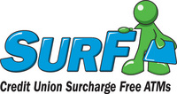](http://www.mainecul.org/right.php/pid/3/sid/10)** C:\Documents and Settings\mfirczak\Local Settings\Temporary Internet Files\Content.Outlook\ME923OAI\creditunionsymbol.jpg [0.75 inch Equal Housing Opportunity Logo]